Requirements for Google Synchronization with Smart Scheduler

So the idea behind a smart scheduler is we want to allow people to schedule events without the tedium of organizing one’s schedule. We hope to use an algorithm (which we are calling Tiler) to optimize the scheduling of events. In order for Tiler to be fully capable we need to integrate third party calendar/scheduling services. We plan to start with google, and later incorporate other services.

Our initial target audience is students. So we are looking at a schedule with frequent repeating events and fairly little updates to the third party calendar.

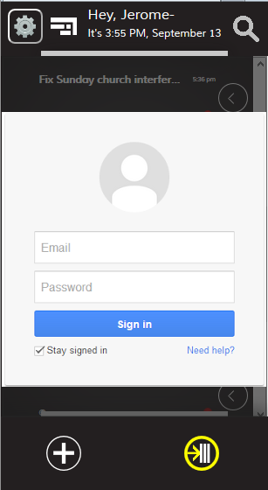Sample Use Case:

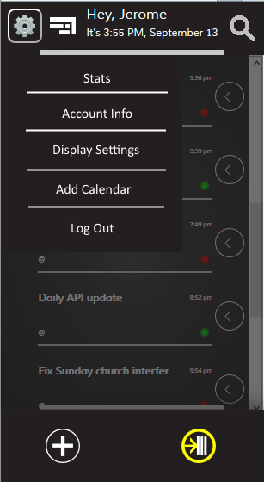

User adds account (1)

Tiler Updates user (5)

Update Tiler Servers with authenticated tokens(2)

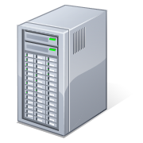

Request for Schedule from your servers (3)

You send schedule formatted in the right way to Tiler (4)

**Tiler Servers**

**Jessica’s Servers**

User adds a third party account by clicking settings and going through Authentication procedure. We retrieve the access tokens. We then send the tokens to the end point Tiler.Azurewebsites.net/api/ ThirdParty. This will be implemented by me. Once the user authenticates our app, I’ll make a call to your (yes, you Jessica☺) end point requesting an update to the user’s schedule.

This is where you come in, I’m hoping you can write a framework, in any language/server of your choosing, to retrieve the schedule from google of a User based on the retrieved token. You can retrieve the token by placing a get request to the same end point “Tiler.Azurewebsites.net/api/ThirdParty” Once retrieved, you can send the events on the schedule to the end point “Tiler.Azurewebsites.net/api/Schedule/ThirdParty” We do not have to worry about security because we can have SSL and CORS handle communication between your end point and mine.

Functional Requirements

The events should be able to provide the event Name, Third party ID, Location (Null by default), Repetition Parameters, Start Time, and End time. Your system must be able to retrieve at least 6 months of schedule data before sending it to my end point. It also should send the schedule in a full batch as opposed to sending one event at a time. It also must be able to handle authentication error, for example in case we lose authentication on a User’s account.

Assumptions

I have looked at the documentation for the google calendar events and they seem quite straight forward and I should be able to map to those variables mentioned above. . It seems like I should be able to a mapping between their events and ours thus creating a quick schedule. As mentioned during our last convo, I am writing up the documentation to make it easy for you to communicate, with our end point. It’ll have information on how to format data for the Tiler End point. You will not need to handle any front end UI work.

Constraints

You might run into constraints from google because of the request available to a user. I will be building a push notification service to listen for event changes to a user’s schedule (I just hope I don’t create an Infinite loop of notifications).